NWU Engineering Design Dev Board — MCU Header Wiring Diagram & Pin Allocation
EEII 321 Group 13 | All Digital Logic Migrated to J3 & J4 (MCP23017 U4) | Labeled by Physical Board Header.Pin (J1.1 – J9.6)
1. Color-Coded MCU Board Header Wiring Diagram
Figure 1 shows the complete pin-by-pin wiring diagram of the NWU Engineering Design ESP32-S3 Dev Board in the exact physical orientation of the carrier PCB (with USB-C J5 at top-left, Comms Expander J1 at top-center, External 5V J2 at top-right, ADS1220 Analog Header J6 at upper-left, High-Speed PWM/Encoder Header J7 at lower-left, and MCP23017 I2C Logic Expander Headers J3 and J4 along the right edge). Figure 2 overlays the header locations onto the physical board photograph.
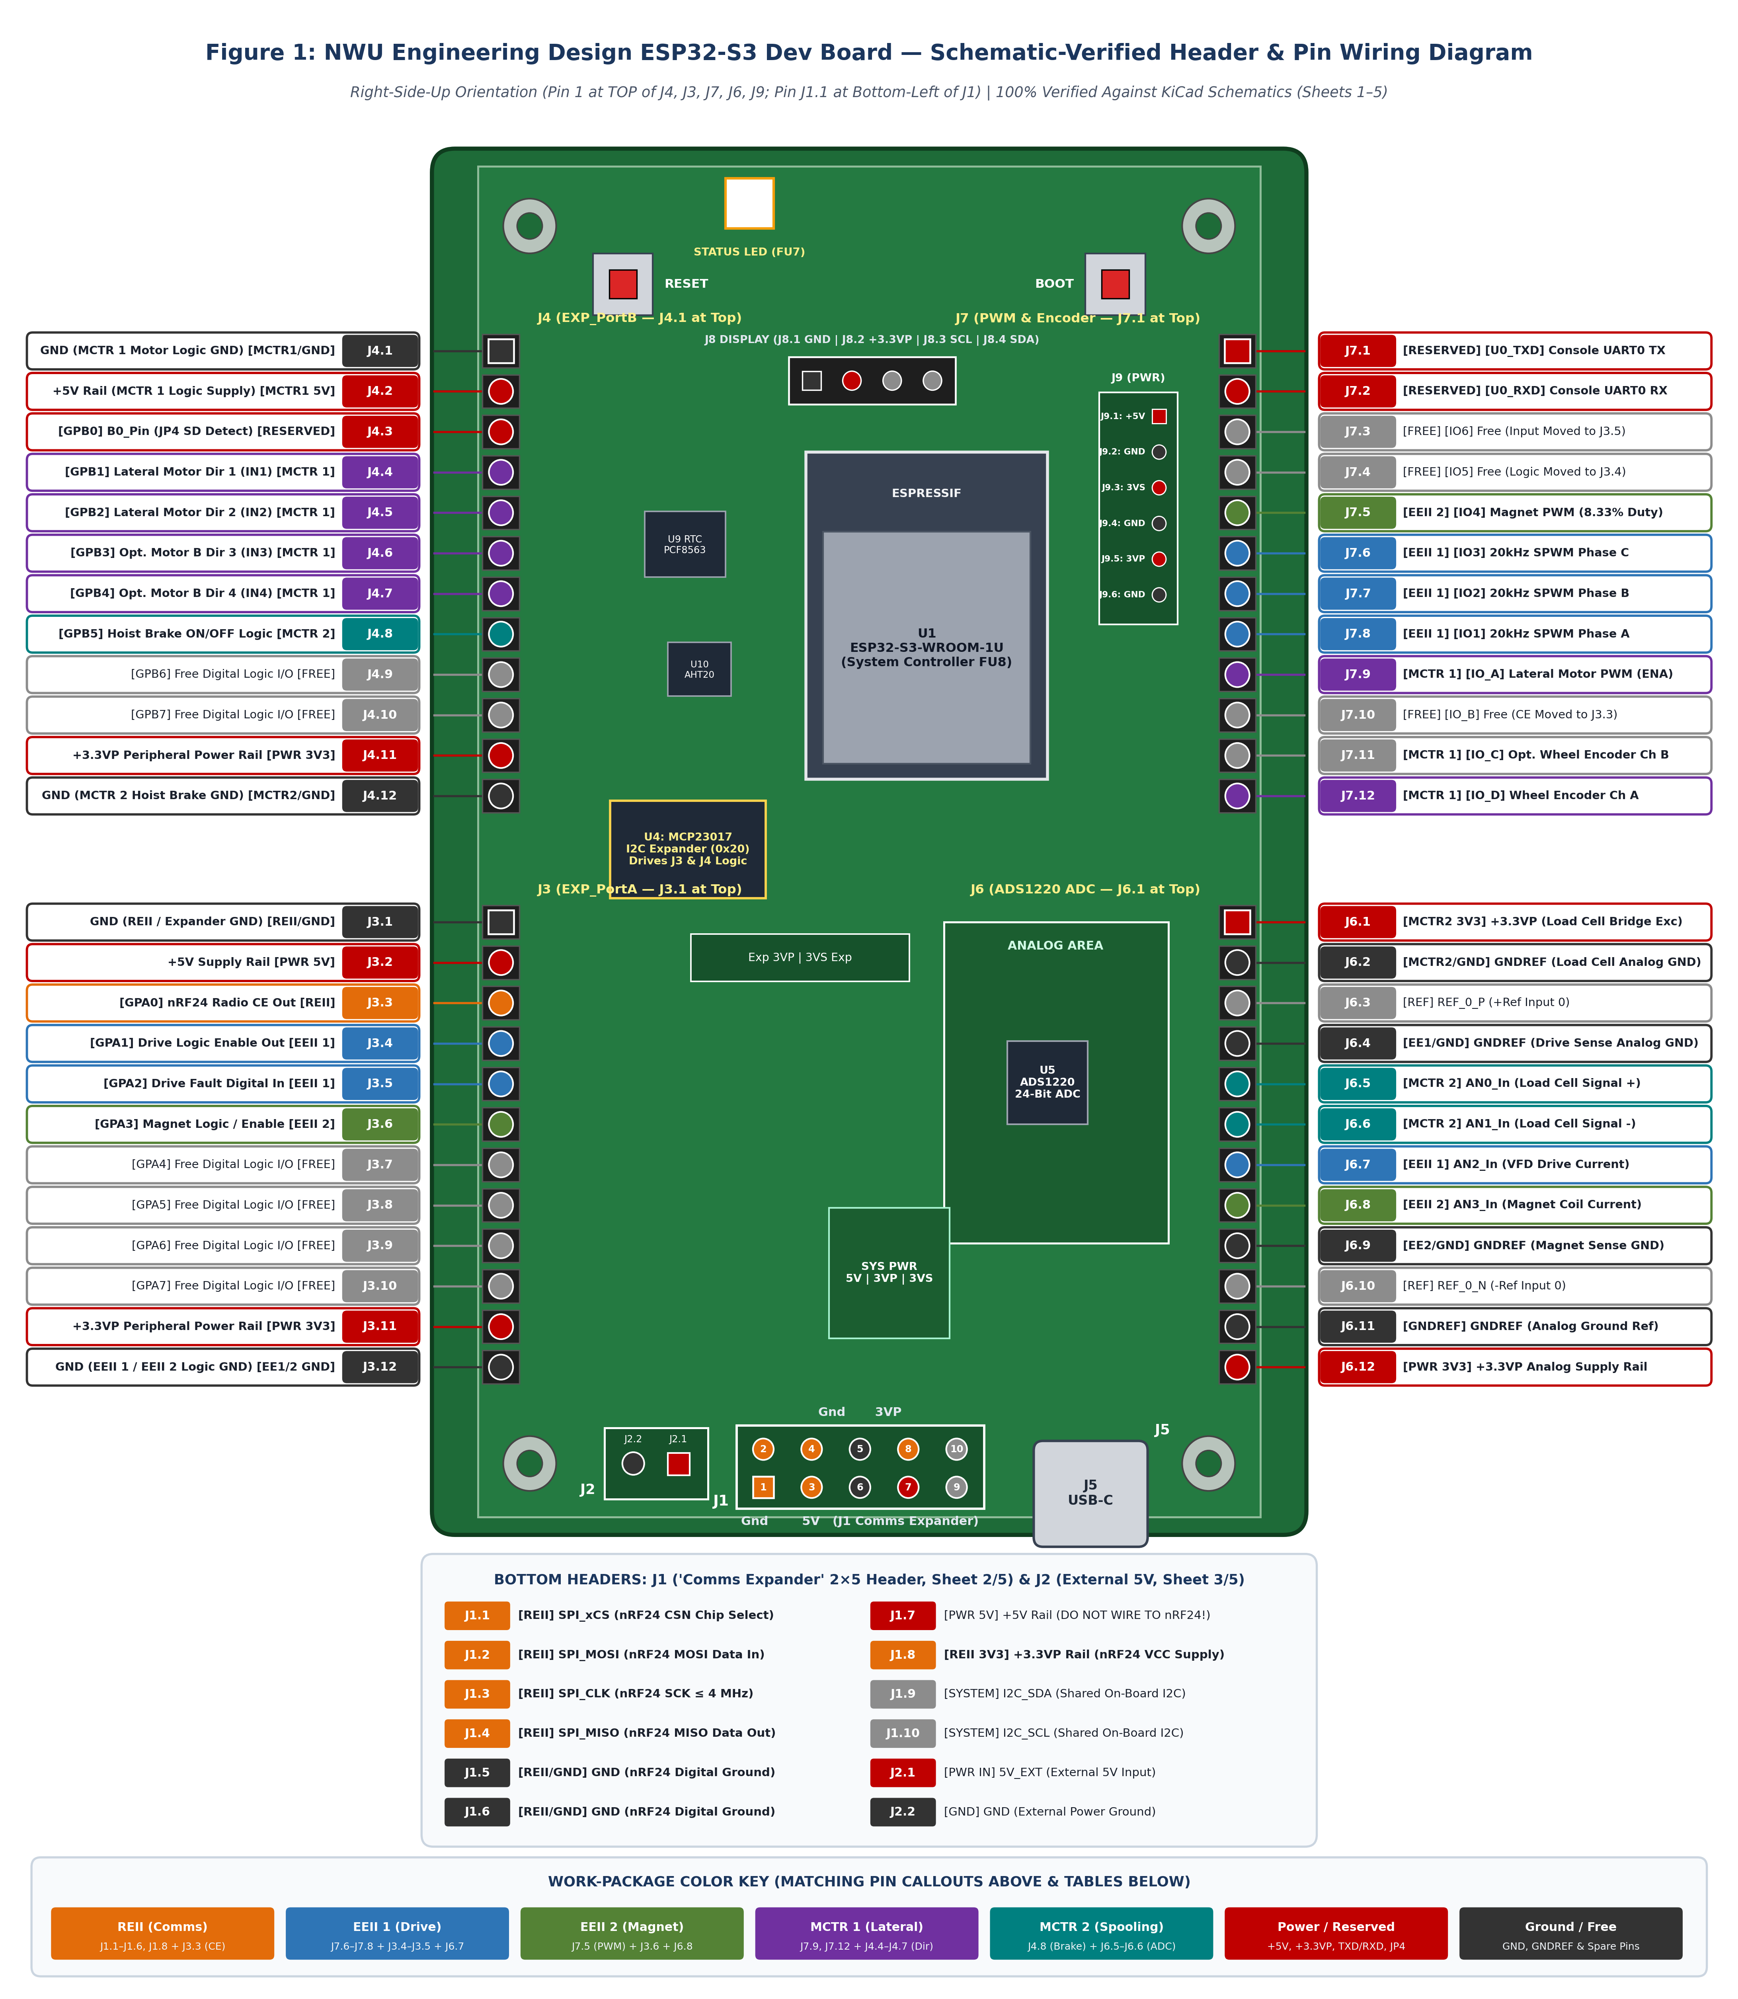
Figure 1: Complete color-coded header and pin wiring diagram (J1–J9) with all package digital logic routed to J3 and J4 (U4 MCP23017).
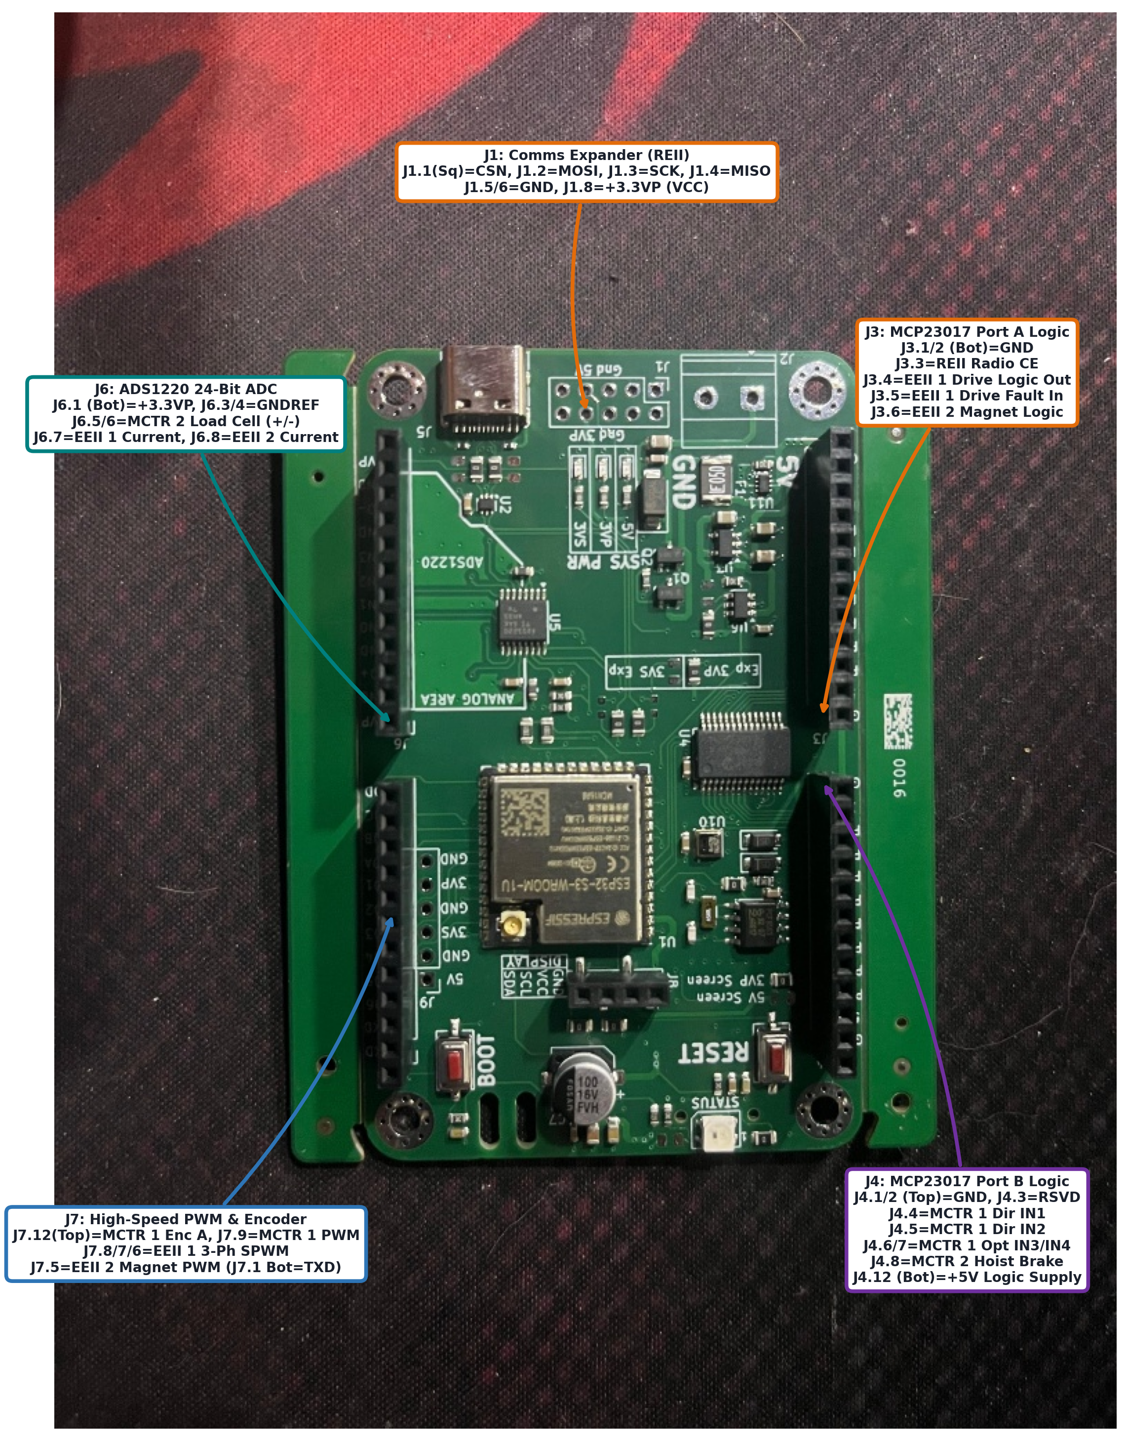
Figure 2: Physical carrier PCB photograph showing exact header locations, Pin-1 orientations, and work-package groupings.
2. Hardware Verifications & J3/J4 Logic Migration Decisions
- All Digital Logic Moved to Headers J3 & J4 (MCP23017 I2C Expander U4): [ALL PACKAGES] Per the official board schematic (Sheet 4/5: I2CPeripherals), the on-board U4 MCP23017 16-bit I2C port expander (I2C Address 0x20 on shared bus I2C_SDA / I2C_SCL) provides 16 buffered 3.3 V digital I/O channels across Header J3 (EXP_PortA: J3.3–J3.10) and Header J4 (EXP_PortB: J4.3–J4.10). Moving every work package's digital HIGH/LOW logic signals (REII Radio CE, EEII 1 Drive Enable & Fault Input, EEII 2 Magnet Logic, MCTR 1 Motor Direction IN1–IN4, and MCTR 2 Hoist Brake ON/OFF) to J3 and J4 eliminates all pin contention on Header J7.
- Header J7 Reserved Strictly for High-Speed PWM & Encoder Pulse Counting: [J7 HIGH-SPEED] Because the I2C expander cannot generate kHz PWM waveforms or count high-frequency shaft encoder edges, Header J7 carries only the hardware-timed signals: EEII 1's 20 kHz 3-phase SPWM outputs (J7.8, J7.7, J7.6), EEII 2's 8.33% duty-cycle Magnet PWM (J7.5), MCTR 1's Lateral Motor Speed PWM ENA (J7.9), and MCTR 1's Lateral Wheel Encoder pulses (J7.12 Channel A, with J7.11 available for Channel B). Four pins on J7 (J7.3, J7.4, J7.10, J7.11) are now completely freed.
- REII Radio Bus on Header J1 + CE Logic on Header J3.3 (No IRQ, Zero Soldering): [REII] The crane nRF24L01+ transceiver connects its 4 MHz SPI bus, CSN (J1.1), GND (J1.5/J1.6), and +3.3VP VCC supply (J1.8) to Header J1 ('Comms Expander'), while its digital Chip Enable (CE) line connects to Header J3.3 (EXP_PortA Pin 3 / GPA0) via a standard 2.54 mm Dupont jumper. Because the crane radio operates in Enhanced ShockBurst PRX mode with hardware Auto-ACK payloads, J3.3 (CE) is driven HIGH once at boot and remains HIGH continuously (0.00 ms runtime latency), while SPI STATUS is polled over J1.1–J1.4 (no IRQ wire needed).
3. Work-Package Pin Allocation Summary (Labeled by Header.Pin)
REII (Remote Control & RF Comms) — Header J1 (SPI) & Header J3 (Logic)
- J1.1 (SPI_xCS): [REII] CSN (SPI Chip Select, active LOW) for the crane nRF24L01+ transceiver.
- J1.2 (SPI_MOSI): [REII] MOSI (Shared 4 MHz SPI master-out data line into radio).
- J1.3 (SPI_CLK): [REII] SCK (Shared ≤ 4.0 MHz SPI Mode 0 clock line).
- J1.4 (SPI_MISO): [REII] MISO (Shared 4 MHz SPI master-in data & STATUS read line).
- J1.5 & J1.6 (GND): [REII / GND] 0 V Digital Ground return (decoupled directly to J1.8 at the radio header with 10 µF electrolytic + 100 nF ceramic capacitors).
- J1.8 (+3.3VP): [REII 3V3] Switched 3.3 V DC supply rail to nRF24L01+ VCC (never connect to J1.7 +5V).
- J3.3 (EXP_PortA GPA0): [REII] CE (Chip Enable digital logic output on U4 MCP23017 Port A; driven HIGH at boot for continuous PRX listen with hardware Auto-ACK payload). IRQ is left unconnected and polled in software.
EEII 1 (Electronic Drive Circuit / VFD) — Header J7 (PWM), Header J3 (Logic) & Header J6 (ADC)
- J7.8 (Silkscreen IO1): [EEII 1] PWM 1 — 20 kHz Hardware SPWM Phase A output to 3-phase inverter.
- J7.7 (Silkscreen IO2): [EEII 1] PWM 2 — 20 kHz Hardware SPWM Phase B output to 3-phase inverter.
- J7.6 (Silkscreen IO3): [EEII 1] PWM 3 — 20 kHz Hardware SPWM Phase C output to 3-phase inverter.
- J3.4 (EXP_PortA GPA1): [EEII 1] Drive Logic / Enable Output — 3.3 V digital HIGH/LOW control signal routed via U4 MCP23017 Port A (moved off J7.4).
- J3.5 (EXP_PortA GPA2): [EEII 1] Drive Fault / Status Digital Input — 3.3 V digital HIGH/LOW protection input routed via U4 MCP23017 Port A (moved off J7.3, eliminating the IO6 silkscreen anomaly).
- J6.7 (ADC_Port AN2_In) & J6.4 (GNDREF): [EEII 1] VFD Current Sensor Analog Input — 24-bit ADS1220 single-ended analog input (filtered via 1 kΩ R24 + 2.2 nF C27).
EEII 2 (Magnet Load Attachment) — Header J7 (PWM), Header J3 (Logic) & Header J6 (ADC)
- J7.5 (Silkscreen IO4): [EEII 2] Magnet PWM — 3.3 V CMOS hardware PWM output (8.33% nominal duty cycle, up to 20 kHz) driving the MOSFET switching module.
- J3.6 (EXP_PortA GPA3): [EEII 2] Magnet Logic Enable / Status — 3.3 V digital HIGH/LOW auxiliary logic line on U4 MCP23017 Port A (with J3.12 as common logic GND).
- J6.8 (ADC_Port AN3_In) & J6.9 (GNDREF): [EEII 2] Magnet Current Sensor Input — 24-bit ADS1220 analog input channel 3 for coil current verification.
MCTR 1 (Lateral Movement) — Header J7 (PWM & Encoder) & Header J4 (Direction Logic)
- J7.9 (Silkscreen IO_A): [MCTR 1] Lateral Motor Speed PWM (ENA) — 1–10 kHz hardware PWM output driving the parallel-wired HW-095 (L298N) H-bridge.
- J7.12 (Silkscreen IO_D): [MCTR 1] Lateral Wheel Encoder Channel A (ENC_A) — High-speed hardware pulse counter input (must be stepped down from 5 V to 3.3 V; 1050 counts/wheel rev).
- J7.11 (Silkscreen IO_C): [MCTR 1 (Opt)] Optional Wheel Encoder Channel B (ENC_B) — Available on J7 if 2-channel quadrature is desired; otherwise left unconnected per Section 3.1.
- J4.4 (EXP_PortB GPB1): [MCTR 1] Motor Direction 1 (IN1) — 3.3 V digital HIGH/LOW output on U4 MCP23017 Port B (moved off J7).
- J4.5 (EXP_PortB GPB2): [MCTR 1] Motor Direction 2 (IN2) — 3.3 V digital HIGH/LOW output on U4 MCP23017 Port B (provides full Forward / Reverse / Brake H-bridge control alongside IN1).
- J4.6 (GPB3) & J4.7 (GPB4): [MCTR 1 (Opt)] Optional Motor B Direction 3 & 4 (IN3 / IN4) — Pre-allocated on J4 in case the second L298N bridge is wired independently instead of jumpered in parallel.
- J4.2 (+5V) & J4.1 (GND): [MCTR 1 PWR] 5 V DC logic power supply and common ground return for the HW-095 motor controller and quadrature encoder.
MCTR 2 (Spooling / Hoist Gearbox & Load Cell) — Header J4 (Brake Logic) & Header J6 (ADC)
- J4.8 (EXP_PortB GPB5) & J4.12 (GND): [MCTR 2] Gearbox Hoist Brake Control (LR7843 MOSFET) — Simple 3.3 V digital HIGH/LOW ON/OFF holding brake actuation via U4 MCP23017 Port B.
- J6.5 (AN0_In) & J6.6 (AN1_In): [MCTR 2] Differential S-Type Hook Load Cell Input (AIN0+ / AIN1−) — Routed to the on-board 24-bit ADS1220 ADC (with 1 kΩ + 2.2 nF anti-aliasing filters).
- J6.1 (+3.3VP) & J6.2 (GNDREF): [MCTR 2 PWR] Regulated 3.3 V bridge excitation supply and low-noise analog ground return for the load cell.
4. Complete Header-by-Header Pin Breakdown (J1, J2, J3, J4, J6, J7, J8, J9)
4.1 Header J1 — 'Comms Expander' (Top-Center, 2×5 Box Header)
Physical Orientation: Pin J1.1 is the square solder pad at the bottom-left of J1. Columns 1–5 from left to right hold pairs (1,2), (3,4), (5,6), (7,8), (9,10).
Pin ID | PCB Silkscreen / Net | Package / Owner | Signal Name | Direction (rel. to MCU) | Function & Wiring Notes
J1.1 | SPI_xCS (Square Pad) | REII (Comms) | CSN | Output | Dedicated active-LOW SPI chip select for crane nRF24L01+.
J1.2 | SPI_MOSI | REII (Comms) | MOSI | Output | Shared 4 MHz SPI bus master-out data line (commands/payloads to radio).
J1.3 | SPI_CLK | REII (Comms) | SCK | Output | Shared ≤ 4.0 MHz SPI Mode 0 clock (shared with on-board ADS1220 & uSD).
J1.4 | SPI_MISO | REII (Comms) | MISO | Input | Shared 4 MHz SPI bus master-in line (reads STATUS & 32B RX frames).
J1.5 | Gnd (Col 3 Bot) | REII / GND | GND | Reference | Digital ground return for crane nRF24L01+ (decouple to J1.8).
J1.6 | Gnd (Col 3 Top) | REII / GND | GND | Reference | Secondary digital ground return on J1.
J1.7 | 5V (Col 4 Top) | Power (+5V) | +5V | Power Rail | WARNING: +5 V rail. Do NOT connect to 3.3 V nRF24L01+ module!
J1.8 | 3VP (Col 4 Bot) | REII (Comms) | +3.3VP (VCC) | Power Rail | Switched 3.3 V supply to crane nRF24L01+ Pin 2 (VCC).
J1.9 | I2C_SDA (Col 5 Top) | System Bus | I2C_SDA | Bidirectional | On-board I2C data bus (drives U4 MCP23017, U9 RTC, U10 AHT20, J8).
J1.10 | I2C_SCL (Col 5 Bot) | System Bus | I2C_SCL | Output | On-board I2C clock bus (3.3 kΩ pull-ups R8/R9 to +3.3VP).
4.2 Header J3 — 'EXP_PortA' MCP23017 Port A Logic Header (Upper-Right Edge, 1×12 Header)
Physical Orientation: Pin J3.1 (GND, square pad) is at the bottom of J3 (next to the 'J3' silkscreen label); Pin J3.12 (+5V) is at the top of J3.
Pin ID | PCB Silkscreen / Net | Package / Owner | Signal Name | Direction (rel. to MCU) | Function & Wiring Notes
J3.1 | GND (Top Pin, Square) | REII / Expander GND | GND | Reference | Common digital ground reference at top of Header J3 (Sheet 4/5).
J3.2 | +5V | Power (+5V Rail) | +5V | Power Rail | 5 V DC supply rail on Pin 2 of Header J3 (Sheet 4/5).
J3.3 | GPA0 (U4 Pin 21) | REII (Comms) | nRF24_CE | Logic Out | Crane nRF24L01+ Chip Enable (CE). Driven HIGH at boot for PRX listen.
J3.4 | GPA1 (U4 Pin 22) | EEII 1 (Drive) | DRV_EN_LOGIC | Logic Out | 3.3 V digital HIGH/LOW enable/control output to VFD drive circuit.
J3.5 | GPA2 (U4 Pin 23) | EEII 1 (Drive) | DRV_FAULT_IN | Logic In | 3.3 V digital HIGH/LOW fault/protection input from drive circuit.
J3.6 | GPA3 (U4 Pin 24) | EEII 2 (Magnet) | MAG_LOGIC | Logic I/O | Auxiliary 3.3 V digital enable/status line for magnet circuit (if used).
J3.7 | GPA4 (U4 Pin 25) | Free (Spare) | EXP_GPA4 | Free I/O | Unassigned MCP23017 Port A digital I/O pin (available for expansion).
J3.8 | GPA5 (U4 Pin 26) | Free (Spare) | EXP_GPA5 | Free I/O | Unassigned MCP23017 Port A digital I/O pin.
J3.9 | GPA6 (U4 Pin 27) | Free (Spare) | EXP_GPA6 | Free I/O | Unassigned MCP23017 Port A digital I/O pin.
J3.10 | GPA7 (U4 Pin 28) | Free (Spare) | EXP_GPA7 | Free I/O | Unassigned MCP23017 Port A digital I/O pin.
J3.11 | +3.3VP | Power (+3.3VP) | +3.3VP | Power Rail | Switched 3.3 V peripheral power rail (U4 VDD bus, Sheet 4/5).
J3.12 | GND (Bottom Pin) | EEII 1 / EEII 2 GND | GND | Reference | Common digital ground return at bottom of Header J3 (Sheet 4/5).
4.3 Header J4 — 'EXP_PortB' MCP23017 Port B Logic Header (Lower-Right Edge, 1×12 Header)
Physical Orientation: Pin J4.1 (GND, square pad) is at the top of J4 (just below J3); Pin J4.12 (+5V) is at the bottom of J4.
Pin ID | PCB Silkscreen / Net | Package / Owner | Signal Name | Direction (rel. to MCU) | Function & Wiring Notes
J4.1 | GND (Top Pin, Square) | MCTR 1 Logic GND | GND | Reference | Common ground return for MCTR 1 HW-095 motor driver & encoder (Sheet 4/5).
J4.2 | +5V | MCTR 1 (+5V Supply) | +5V | Power Rail | 5 V DC logic supply to MCTR 1 HW-095 motor driver and wheel encoder (Sheet 4/5).
J4.3 | B0_Pin (GPB0 / JP4) | Reserved (SD Detect) | B0_Pin / MMC_CD | Reserved | Shared with microSD Card Detect via jumper JP4; leave unconnected.
J4.4 | GPB1 (U4 Pin 2) | MCTR 1 (Lateral) | MOT_IN1 | Logic Out | 3.3 V digital HIGH/LOW H-bridge Direction 1 input to HW-095 (L298N).
J4.5 | GPB2 (U4 Pin 3) | MCTR 1 (Lateral) | MOT_IN2 | Logic Out | 3.3 V digital HIGH/LOW H-bridge Direction 2 input to HW-095 (L298N).
J4.6 | GPB3 (U4 Pin 4) | MCTR 1 (Optional) | MOT_IN3 (Opt) | Logic Out | Optional H-bridge channel B Direction 3 (if 2nd bridge not paralleled).
J4.7 | GPB4 (U4 Pin 5) | MCTR 1 (Optional) | MOT_IN4 (Opt) | Logic Out | Optional H-bridge channel B Direction 4 (if 2nd bridge not paralleled).
J4.8 | GPB5 (U4 Pin 6) | MCTR 2 (Spooling) | HOIST_BRAKE | Logic Out | 3.3 V digital HIGH/LOW ON/OFF holding brake command to LR7843 MOSFET.
J4.9 | GPB6 (U4 Pin 7) | Free (Spare) | EXP_GPB6 | Free I/O | Unassigned MCP23017 Port B digital I/O pin.
J4.10 | GPB7 (U4 Pin 8) | Free (Spare) | EXP_GPB7 | Free I/O | Unassigned MCP23017 Port B digital I/O pin.
J4.11 | +3.3VP | Power (+3.3VP) | +3.3VP | Power Rail | Switched 3.3 V peripheral power rail (U4 VDD bus, Sheet 4/5).
J4.12 | GND (Bottom Pin) | MCTR 2 Brake GND | GND | Reference | Common ground return for MCTR 2 LR7843 hoist brake module at bottom of J4 (Sheet 4/5).
4.4 Header J6 — 'ADC_Port' ADS1220 24-Bit Analog Header (Upper-Left Edge, 1×12 Header)
Physical Orientation: Pin J6.1 (+3.3VP, square pad) is at the bottom of J6 (next to the 'J6' silkscreen label); Pin J6.12 (+3.3VP) is at the top of J6.
Pin ID | PCB Silkscreen / Net | Package / Owner | Signal Name | Direction (rel. to MCU) | Function & Wiring Notes
J6.1 | VP (Top Pin, Square) | MCTR 2 (+3.3VP) | +3.3VP | Power Rail | 3.3 V excitation supply to S-type load cell bridge (Sheet 5/5).
J6.2 | GND (GNDREF) | MCTR 2 Analog GND | GNDREF | Reference | Filtered low-noise analog ground return for MCTR 2 load cell bridge (Sheet 5/5).
J6.3 | R0+ (REF_0_P) | ADC Reference | REF_0_P | Ref Input | ADS1220 external positive reference input 0 (Sheet 5/5).
J6.4 | GND (GNDREF) | EEII 1 Analog GND | GNDREF | Reference | Filtered low-noise analog ground return for EEII 1 current sensor (Sheet 5/5).
J6.5 | AN0 (AN0_In) | MCTR 2 (Spooling) | LOADCELL_P | Analog In | Load cell differential signal + (ADS1220 AIN0 via 1 kΩ R17 + 2.2 nF C23).
J6.6 | AN1 (AN1_In) | MCTR 2 (Spooling) | LOADCELL_N | Analog In | Load cell differential signal − (ADS1220 AIN1 via 1 kΩ R18 + 2.2 nF C24).
J6.7 | AN2 (AN2_In) | EEII 1 (Drive) | VFD_CURR_IN | Analog In | Drive circuit current sensor input (ADS1220 AIN2 via 1 kΩ R24 + 2.2 nF C27).
J6.8 | AN3 (AN3_In) | EEII 2 (Magnet) | MAG_CURR_IN | Analog In | Electromagnet current sensor input (ADS1220 AIN3 via 1 kΩ R27 + 2.2 nF C28).
J6.9 | GND (GNDREF) | EEII 2 Analog GND | GNDREF | Reference | Filtered low-noise analog ground return for EEII 2 current sensor (Sheet 5/5).
J6.10 | R0- (REF_0_N) | ADC Reference | REF_0_N | Ref Input | ADS1220 external negative reference input 0 (Sheet 5/5).
J6.11 | GND (GNDREF) | Analog Ground | GNDREF | Reference | Filtered low-noise analog ground reference on Pin 11 (Sheet 5/5).
J6.12 | VP (Bottom Pin) | Power (+3.3VP) | +3.3VP | Power Rail | Switched 3.3 V analog supply rail at bottom of Header J6 (Sheet 5/5).
4.5 Header J7 — Direct MCU High-Speed PWM & Encoder Header (Lower-Left Edge, 1×12 Header)
Physical Orientation: Per schematic Sheet 2/5 and PCB silkscreen, J7.1 ('TXD', square pad) is at the bottom near the BOOT button, ascending to J7.12 ('D' / IO_D) at the top just below J6. Always verify the silkscreen character (TXD, RXD, 6, 5, 4, 3, 2, 1, A, B, C, D) printed next to each pin.
Pin ID | PCB Silkscreen / Net | Package / Owner | Signal Name | Direction (rel. to MCU) | Function & Wiring Notes
J7.1 | TXD (Bottom Pin) | Reserved (UART0) | U0_TXD | Reserved | Console UART0 TX (near BOOT button); do not wire external loads.
J7.2 | RXD | Reserved (UART0) | U0_RXD | Reserved | Console UART0 RX; do not wire external loads.
J7.3 | 6 (Silkscreen IO6) | Free (Moved to J3.5) | IO6 (Free) | Free Pin | Freed by moving EEII 1 digital fault input to J3.5 (avoids IO6 net anomaly).
J7.4 | 5 (Silkscreen IO5) | Free (Moved to J3.4) | IO5 (Free) | Free Pin | Freed by moving EEII 1 drive logic output to J3.4.
J7.5 | 4 (Silkscreen IO4) | EEII 2 (Magnet) | MAG_PWM | PWM Out | 3.3 V CMOS hardware PWM (8.33% duty cycle, up to 20 kHz) to MOSFET module.
J7.6 | 3 (Silkscreen IO3) | EEII 1 (Drive) | VFD_SPWM_C | PWM Out | 20 kHz hardware MCPWM Phase C output to 3-phase inverter.
J7.7 | 2 (Silkscreen IO2) | EEII 1 (Drive) | VFD_SPWM_B | PWM Out | 20 kHz hardware MCPWM Phase B output to 3-phase inverter.
J7.8 | 1 (Silkscreen IO1) | EEII 1 (Drive) | VFD_SPWM_A | PWM Out | 20 kHz hardware MCPWM Phase A output to 3-phase inverter.
J7.9 | A (Silkscreen IO_A) | MCTR 1 (Lateral) | LAT_PWM_ENA | PWM Out | 1–10 kHz hardware LEDC PWM speed output to HW-095 motor controller ENA.
J7.10 | B (Silkscreen IO_B) | Free (Moved to J3.3) | IO_B (Free) | Free Pin | Freed by moving REII radio CE pin to J3.3.
J7.11 | C (Silkscreen IO_C) | MCTR 1 (Optional) | ENC_B / Free | Pulse In | Freed by moving MCTR 1 direction to J4.4/J4.5; available for Encoder Ch B.
J7.12 | D (Top Pin, IO_D) | MCTR 1 (Lateral) | ENC_A | Pulse In | Single-channel wheel encoder pulse input (3.3 V level-shifted; 1050 CPR).
4.6 Headers J2 (External 5V), J8 (I2C Display) & J9 (Auxiliary Power Rails)
Auxiliary power and I2C display headers on the carrier PCB.
Pin ID | PCB Silkscreen / Net | Package / Owner | Signal Name | Direction (rel. to MCU) | Function & Wiring Notes
J2.1 | 5V (Top-Right) | System Power In | 5V_EXT | Power In | External 5 V DC input (protected by Q1/Q2 reverse-polarity MOSFETs & 500 mA fuse F1).
J2.2 | GND (Top-Right) | System Power GND | GND | Reference | External 5 V ground return.
J8.1 | GND (Bottom-Center) | Display GND | GND | Reference | Optional I2C OLED display ground.
J8.2 | VCC (Bottom-Center) | Display Power | +3.3VP | Power Out | 3.3 V display power rail (selected via 0Ω jumper R47).
J8.3 | SCL (Bottom-Center) | System I2C Bus | I2C_SCL | Clock Out | Shared on-board I2C clock line (OLED address 0x3C / 0x3D).
J8.4 | SDA (Bottom-Center) | System I2C Bus | I2C_SDA | Data I/O | Shared on-board I2C data line.
J9.1 | 5V (Inner Left Bot) | Power Distribution | +5V | Power Rail | +5 V rail breakout next to J7.
J9.2 | GND | Ground | GND | Reference | Common digital ground.
J9.3 | 3VS | Power Distribution | +3.3V | Power Rail | Always-on +3.3 V system rail.
J9.4 | GND | Ground | GND | Reference | Common digital ground.
J9.5 | 3VP | Power Distribution | +3.3VP | Power Rail | Switched +3.3VP peripheral rail.
J9.6 | GND (Inner Left Top) | Ground | GND | Reference | Common digital ground.

